Project 2

**Examining the Relationship between total deaths registered and Political Representation**

Bharosa Gauchan, Mardochee Duffaut, Alexia Vasquez

Bellevue University- May 18, 2024

Table of Contents

Introduction 2

Business Problem/Hypothesis 4

Methods/Analysis 4

Results 8

Recommendations/Ethical Considerations 9

Conclusion 9

10 Questions 10

References 12

Appendix 13

# Introduction

Our life has been greatly affected these last years, whilst simultaneously having substantial challenges for our future and current generations, due to the COVID -19 pandemic that has emerged, and created a tremendous impact on public health. Having the ability to control the viral spread, and mitigating its impact, has become one of the top concerns for every country on the globe (J.R Zahar et al., 2022). Around the globe, political conflicts and coverage surrounding the nature and risk of the virus set the stage for segments of the public to be relatively more receptive to misinformation about COVID-19 vaccines. It is important to note the percentage of loss of human lives during this period has been influenced by information, the current state of the epidemic, and a variety of individual-level characteristics. Politicization surrounding COVID-19 vaccines contributed to hesitancy, resistance, and opinion polarization. Our project’s main goal is to show that in the U.S, the total death across the country is based on large differences existed in opinions between Republicans and Democrats.

To accomplish this project, we will be using a comprehensive data set that has included various metrics related to public health initiatives and outcomes during the pandemic. The dataset sourced from the CDC includes records detailing the number of administered vaccine doses per age group, per 100k pop, and other variables that influenced public health metrics. The key metrics we used for this report are:

* **jurisdiction (state/territory) or federal entity** - Record of each state applicable to the tested parameters.
* **Total Doses Distributed Per 100k population –** The total number of distributed doses per 100k Pop to have a more comparable measure between large and smaller states.
* **Deaths per 100k Pop –**The total number of death for each 100k population.
* **Political affiliation-**Record of the political position of the jurisdiction or state
* **Total doses administered by jurisdiction-** The total number of distributed doses per state or jurisdiction.

By analyzing these specific variables, our project aims to uncover if there is a direct impact on death rate and political affiliation across the states.

# Business Problem/Hypothesis

The business problem we are addressing in this study is determining the relation between a jurisdiction's political affiliation and the total death registered. Our hypothesis is that the states affiliated to Republicans do have a positive correlation with the overall death rates than the ones affiliated to Democrats. Democratic states will in turn demonstrate lower rate in death than those Republicans ones.

# Methods/Analysis

Our data scientist’s approach is structured into four separate phases, with a focus on analyzing the impact of political affiliation based off death rates across each U.S State. We have linked data from the CDC and different academic studies, to specifically examine the effectiveness of the different public health strategies in enhancing vaccination rates.

**Phase 1: Data gathering and processing.**

The data wrangler for this project collected data from two main sources. The first is the CDC’s Global Covid–19 Vaccine Tracker, and the second is the JAMA Network on state–level vaccine incentives. The initial task was assessing the quality of the data and then preparing it for analysis. This process involved:

* Identifying and correcting any inconsistencies in data types.
* Handling missing values, especially in critical fields like vaccine distribution and administration rates.
* Standardizing categorical data such as incentive types and political affiliation to ensure consistency across the datasets.

The above table shows a summary statistic of the numerical values of our dataset.

**Phase 2: Exploratory Data Analysis (EDA)**

After the data was cleaned, our team conducted an EDA on it to understand the distribution and correlation between the variables. Our primary steps included:

* Utilizing histogram to visualize the distribution of vaccines doses per 100k population.

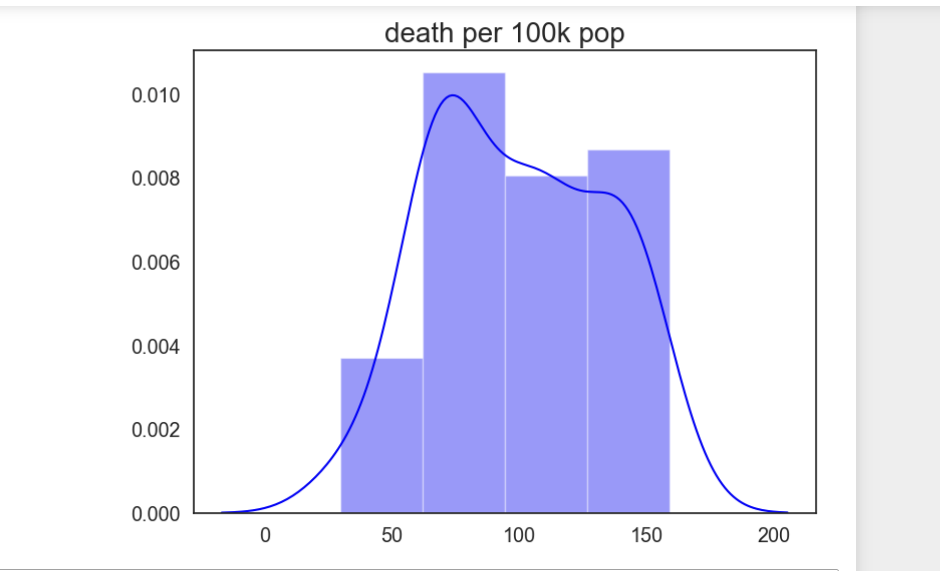

Most of the jurisdictions have a total death per 100k pop between 60 and 100.

* Employing map chart to understand the distribution of deaths per 100k population versus political affiliation of states and jurisdictions.

**Phase 3: Comparative Analysis**

Our comparative analysis was focused on the correlation of deaths per 100k population according to the state’s affiliation to politics.

We compared the total deaths per 100k population between states based on their political affiliation (i.e. Democrat (D) or Republican (R)).

**Phase 4: Statistical Modeling**

To predict and interpret the impact of the political affiliation of states, we applied the Logistic regression Random Forest model for classification and the Classification Tree model.

We refined our models, incorporating only the statistically significant variables to enhance the accuracy and relevance to our findings.

Here is a summary of the performance of our three models.

* Logistic Regression 67.5%
* Classification Tree 75%
* Random Forest 70%

# Results

Our Preliminary analysis indicates that there is slight association between a state’s political affiliation and the overall number of deaths per 100k population. Republican States in fact exhibit slight difference in death rates compared to Democrat ones.

# Recommendations/Ethical Considerations

Based on our findings from the final analysis, we would recommend policymakers prioritize the battle of fighting misinformation and pushing more public health programs that are aimed at informing the public of true information regarding the virus and the deaths related. We believe that we would have a higher benefit in attempting more vaccinated individuals, versus any political propaganda that mislead the public opinion on the vaccination programs. considerations would be to include ensuring transparency in handling sensitive information regarding the vaccine, the deaths, and virus, as well as trying to mitigate potential biases in vaccine manufacturers, effectiveness, and vaccines distribution across the country.

# Conclusion

To conclude, our team study highlighted that this project has the potential to contribute significantly to public health initiatives by uncovering political factors influencing vaccine hesitancy and misinformation ultimately leading to better vaccine coverage and improved population health.

By leveraging statistical and comparative analysis, we have identified key insights into the effectiveness of public health interventions during the COVID-19 pandemic. We believe these findings have implications for potential future vaccination strategies and any pandemic preparedness efforts.

# 10 Questions

1. What is the goal of studying the impact of political representation on vaccine distribution?

- The goal is to understand how political beliefs and party dominance in state governments influence the strategies, efficiency, and participation of receiving vaccines. This helps us to assess whether political alignment affects public health outcomes and their participation.

2. How can political representation affect vaccine participation?

- Political representation can affect vaccine participation through policy advertisement and support, public prioritization of groups, funding allocation, public communication strategies, and cooperation with federal directives, all of which can vary depending on the governing party’s philosophy, beliefs and objectives.

3. What data sources are useful for analyzing the impact of political representation on vaccine distribution?

- Useful data sources we used include state government health department records, CDC vaccine distribution and uptake statistics, party affiliation of state legislatures, and demographic data on state populations.

4. What metrics are being used to measure the effectiveness of vaccine distribution?

- The metric we are using to measure effectiveness is the total doses distributed per 100k pop. The higher the amount, determines ore success.

5. How might vaccine distribution differ between politically conservative and liberal states?

- Conservative states might prioritize personal freedom, potentially leading to less restrictive distribution policies. Liberal states might focus more on stricter adherence to public health guidelines.

6. What statistical methods can be used to analyze the relationship between political representation and vaccine distribution outcomes?

- Random Forests can be used to assess relationships between political variables (like party in power) and vaccination metrics.

7. Are there case studies that show clear examples of how political representation influenced vaccine policy?

- Yes, comparing states like Florida and New York could provide insights as each has had different political leadership and distinct approaches to public health during the pandemic, affecting vaccine rollout strategies and compliance.

8. What role do federal policies play in moderating the impact of state-level political representation on vaccine distribution?

- Federal policies can set baseline standards and provide funding and resources, but state-level political representation can influence the implementation of these policies, including the speed and manner of vaccine rollout, and how public sentiment grows.

9. How can public opinion on vaccination be influenced by political representation?

- Political leaders' public statements and policies can significantly influence public opinion, potentially leading to higher levels of vaccine hesitancy in states where leaders are skeptical of vaccines or lower hesitancy in states promoting vaccine benefits.

10. What are the potential long-term effects of politicizing vaccine distribution on public health?

- Politicization can lead to mistrust in vaccines and public health authorities, disparities in health outcomes across different political regions, and potentially hindered responses to future public health crises due to entrenched political beliefs affecting public compliance and policy effectiveness.

# References

1. CDC. (2020, March 28). COVID Data Tracker. Centers for Disease Control and Prevention. <https://covid.cdc.gov/covid-data-tracker/>
2. COVID-19: Data on vaccines - NYC Health. (n.d.). <https://www1.nyc.gov/site/doh/covid/covid-19-data-vaccines.page>
3. Coronavirus disease (COVID-19) – World Health Organization. (2024, April 5). <https://www.who.int/emergencies/diseases/novel-coronavirus-2019>
4. Pfizer coronavirus resources: COvid-19 updates, news, information | Pfizer. (n.d.). <https://www.pfizer.com/science/coronavirus/vaccine>
5. National Institutes of Health (NIH). (n.d.). National Institutes of Health (NIH). <https://www.nih.gov/>
6. Journal of Public Health Policy | palgrave. (n.d.). <https://www.palgrave.com/gp/journal/41271>
7. U.S. Department of Health and Human Services. (2021). Vaccines National Strategic Plan 2021–2025. In Vaccines National Strategic Plan 2021–2025 [Report]. <https://www.hhs.gov/sites/default/files/HHS-Vaccines-Report.pdf>
8. US Department of Health and Human Services/Centers for Disease Control and Prevention/National Center for Immunization and Respiratory Diseases. (n.d.). Increasing COVID-19 Vaccine Uptake among Members of Racial and Ethnic Minority Communities: A Guide for Developing, Implementing, and Monitoring Community-Driven Strategies. <https://www.cdc.gov/vaccines/covid-19/downloads/guide-awardees-community-driven-strategies.pdf>
9. Hogan, C., Parzuchowski, A., Lyu, X., Goldstick, J. E., & Resnicow, K. (2022). Characterization of US state COVID-19 vaccine incentive programs. JAMA Network Open, 5(10), e2235328. <https://doi.org/10.1001/jamanetworkopen.2022.35328>
10. Hacisuleyman, E., Hale, C., Saito, Y., Blachère, N. E., Bergh, M., Conlon, E. G., Schaefer-Babajew, D., DaSilva, J., Muecksch, F., Gaebler, C., Lifton, R. P., Nussenzweig, M. C., Hatziioannou, T., Bieniasz, P. D., & Darnell, R. B. (2021). Vaccine Breakthrough Infections with SARS-CoV-2 Variants. New England Journal of Medicine/the New England Journal of Medicine, 384(23), 2212–2218. <https://doi.org/10.1056/nejmoa2105000>

11. J.R Zahar, D. Seytre, P. Moenne-Locoz, A. Lomont, & Y. Tandjaoui-Lambiotte. (2022). *Spread of viruses, Which measures are the most apt to control COVID-19?* National Library of Medicine. <https://www.ncbi.nlm.nih.gov/pmc/articles/PMC9746078/>

1. 12 COVID-19 vaccination strategies for your community. (2022, November 29). Centers for Disease Control and Prevention. <https://www.cdc.gov/vaccines/covid-19/vaccinate-with-confidence/community.html>

# Appendix

